User Manual for Team Member - [Client Name]

Microsoft® Office Enterprise Project Management Solution
TEAM MEMBER



AstroWix Corporation
Email: info@astrowix.com



AstroWix India Project Solutions Pvt. Ltd.
Delhi NCR Office
A-57, Sector 16
Noida 201 301, INDIA
Phone: +91 120 431 5760, Fax: +91 120 431 5766
Email: info@astrowix.com
Bangalore Office
484, II Cross, 25th Main
BTM Layout II Stage
Bangalore - 560 076, INDIA
Phone: +91 80 2678 5916
Email: info@astrowix.com
Table of Contents
INTRODUCTION 4
Project Web Access 5
1. Home Page 5
2. Report the status of my tasks 6
What do the indicators on the Tasks page mean? 6
Submit the status of tasks 6
Add a note about my task status 8
3. Manage timesheets 11
View your timesheets 11
Submit my timesheet 11
Recall a timesheet 13
Recall a submitted timesheet as a timesheet owner 13
4. Manage status reports 14
Submit a status report 14
Submit an unrequested status report 15
5. Alert or remind me of changes with e-mail notifications 17
About alerts and reminders 17
Set notifications for yourself 17
6. Project Workspace 19

INTRODUCTION
Audience:
This manual is meant for the users at [Client Name]. Users of this manual should have basic working knowledge of computers.

Purpose of this document:
The purpose of this document is to provide an interface between the user and the EPM. It will help users to update the progress of various activities, view the Schedule of the projects, view all the reports related to [Client-DOMAIN], publish and track the baseline plans for a particular project or a group of project.

Scope:
It provides operating knowledge of the Web based Enterprise Project Management System for [Client Name]

Project Web Access

Home Page
The Project Web Access home page is the primary entry point for users who work with data saved to the Microsoft Office Project Server 2007 database. When you log on to Project Web Access, pending items that might require action (such as task updates that must be approved) and items that have changed since the last time that you logged on are displayed. From the home page, you can access Project Web Access features, including Tasks, Project Center, Resource Center, Updates, Status Reports, Issues, and Risks pages.
Note: Team Member don’t have the permission to view Project Center view, so Team Member are unable to view the Enterprise projects.
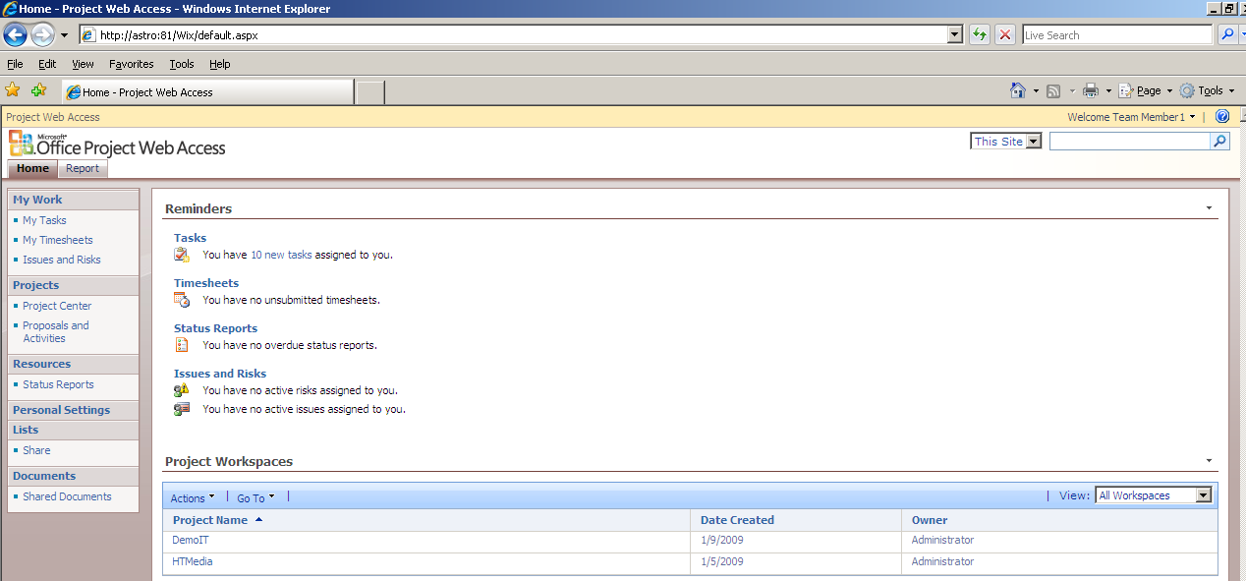

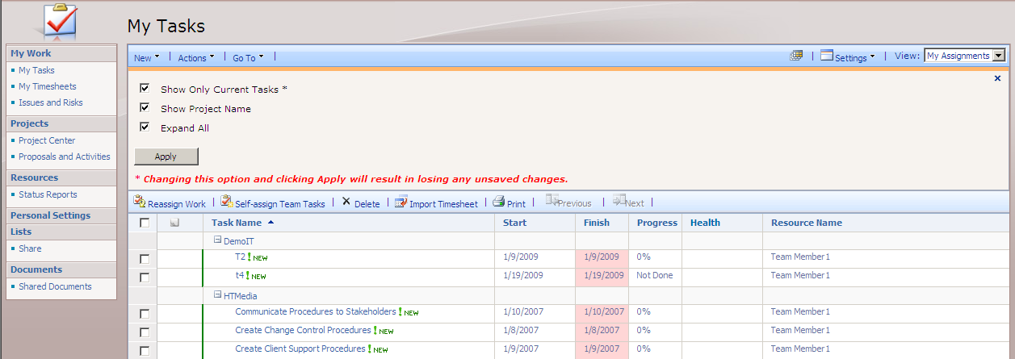

Report the status of my tasks
In Microsoft Office Project Web Access, task status captured numerically as hours.

What do the indicators on the Tasks page mean?

The Tasks page displays your assigned tasks (task: An activity that has a beginning and an end. Project plans are made up of tasks.) and may display a number of graphical indicators (indicators: Small icons representing information for a task or resource that are displayed in the Indicators field. The Indicators field is located to the right of the ID field and appears in a number of tables.). The following table describes these indicators and their meanings.
Indicator | Meaning | Recommended action
 | The task was added since you last viewed this page. | No action required. If you want to request that this assignment be deleted, delete the new task.
 | The Actual were rejected by the project manager. | Contact your project manager to resolve the problem, and then resubmit the actuals.
 | The assignment was changed since you last saved its status. Any changes you made were overwritten with those made by the project manager. | Review the changes to the assignment, and consult with the project manager as needed.
 | You entered the status and saved it, but the status has not yet been submitted. | No action required. Click Submit Selected when you are ready to send the status to your manager.
 | A note is attached to this task. | Click the note indicator to read the note.
 | A document is associated with this task. | Select the task, and then select a document from the list to view it.
 | A risk is associated with this task. | Select the task, and then select a risk from the list to review it.
 | An issue is associated with this task. | Select the task, and then select an issue from the list to review it.

Submit the status of tasks
Task status is submitted separately from your timesheet. Task status is sent to the project manager, and it reports on your progress toward completion of your tasks..
- On the Quick Launch, under My Work, click My Tasks.
- In the Progress column, enter the status of each task or project. Depending on the requirements of your organization and its project managers, you may be required to enter progress for a task in one of three different ways:
  - Actual work done and work remaining [Example: 5d] Type the total time you worked on this task to date. Type the time as a number followed by h for hours, d for days, w for weeks, or mo for months.
- Update the assigned task using Completed work, Actual Start, Remaining Work

Notes:
- Remaining Work
Scenarios – examples:
- If a single day Task is On Time Complete and if Planned Dates are same than Actual Dates
- Completed Work = “Actual” Work
- Remaining Work = 0
- If a single day Task is Delayed or Early Complete and if Planned Start Date is different than Actual Start Date
- Completed Work = Actual Work
- Remaining Work = 0
- Select Start = Actual Start Date
- If a Task is In progress and if Planned Start Date is different than Actual Start Date
- Completed Work = Actual Work
- Remaining Work = Actual Reaming work
- Start = Actual Start
Tip Click Recalculate to see the impact of the actual work data that you entered.
- Select the Send Comment check box if you want to send a comment about your status to the status manager.
- Select the check box in the left column for each task that you want to submit, and then click Submit Selected.
If you chose to include a comment for your status manager, a window appears. Type your comments about your status in the box in this window, and then click OK. Your status is submitted.
Notes
- If the remaining work value for the task needs to be updated, click the name of the task in the Task Name column. On the Assignment Details page, update the Remaining Work box with a current estimate of time to completion.
- To save your status without submitting it to the status manager, click Save All instead of Submit Selected. This saves your changes but does not change the data that your manager or team members see.

Add a note about my task status
If you have comments about the numeric status data that you entered for a task on the My Tasks page, you can add a note to the task for review by the project manager. Notes added to specific tasks are separate from the comments that you enter when submitting your task status. These notes are also different from the narrative status that you enter on the Status Report page.
- On the Quick Launch, under My Work, click My Tasks.
- Point to the task for which you want to add a note, click the arrow that appears, and then click Add/Edit Note. The Project Web Access Assignment Notes dialog box opens with a list of the existing notes for the task, as well as a box to enter a new note.
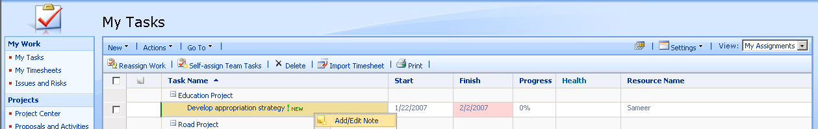
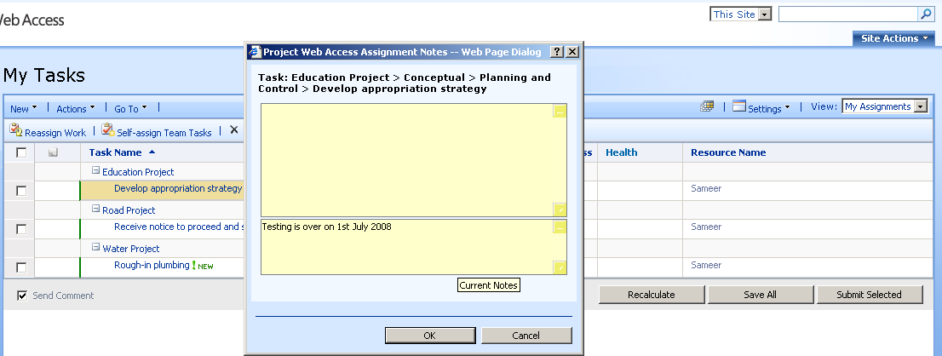
- Type your text in the bottom box, and then click OK.
- Click Save All to save the note.
Notes
- After adding a note, you must save your task status to save the note. If you close the browser window or navigate away from the My Tasks before saving your task status, the note will be lost.

When we click on a task in my task :
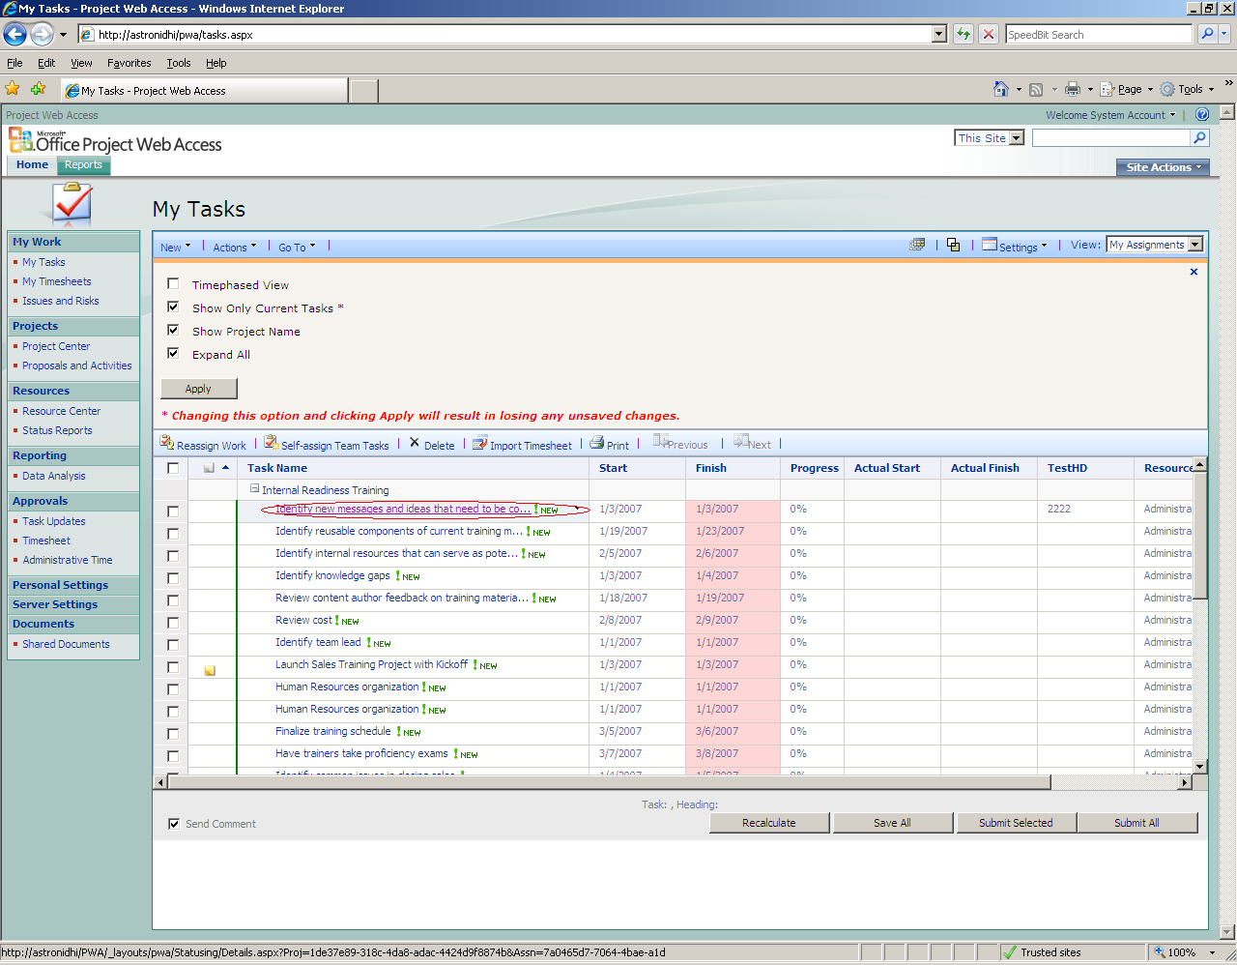

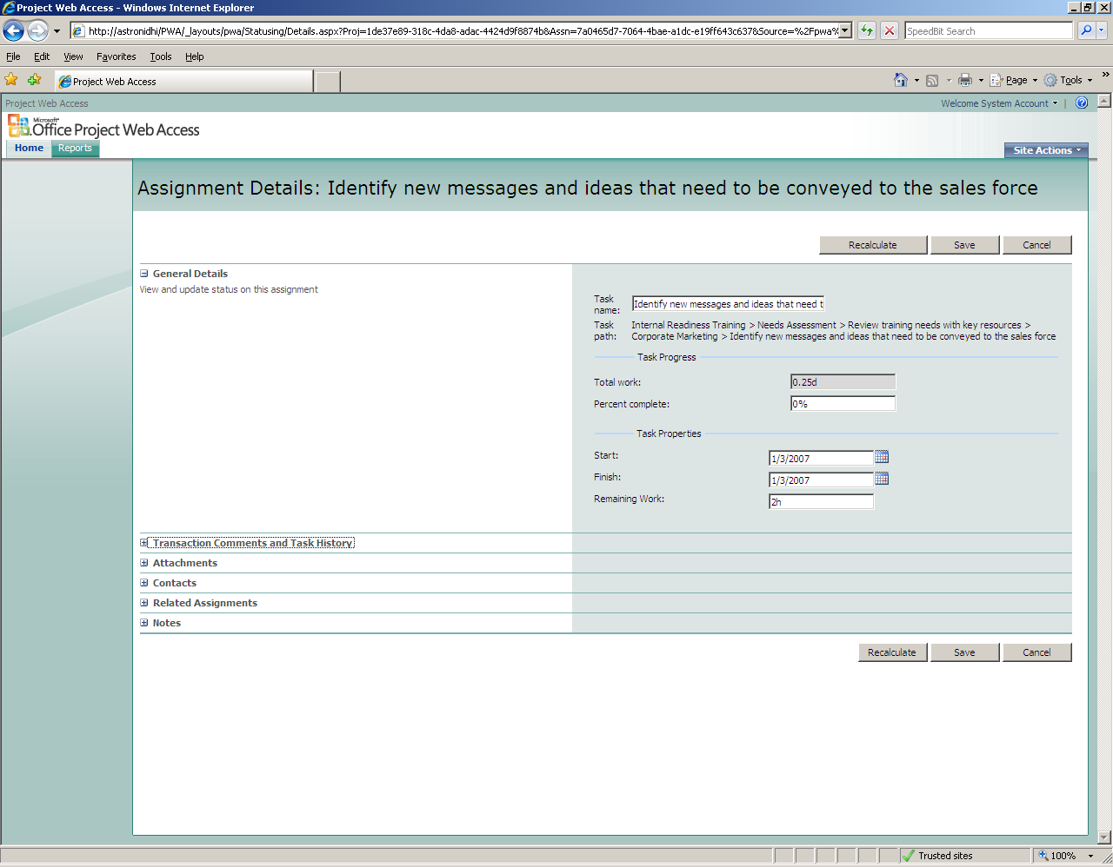
We can see general details, Transaction Comments and Task History, Attachments, Contacts, Related Assignments and Notes.
General details showing basic information of task like Task Name, Task Path, Start and Finish date of task, Remaining work and % complete of Task.
Transaction Comments and History maintains history of task changes, update details (date,name etc..) and approvals also.
Attachments : If any issue,Risk and documents attached with task.
Contacts: Include Project Team (Including Project Manager, Team Members, Team Leaders, Executive whole project team)
Related Assignments : It showing Task Dependencies
Notes: If any Note attached then we can see, or can attach also

Manage timesheets

Timesheets (timesheet: In Project Web Access, the timesheet is a page where resources can record their progress on tasks and send updates to the Timesheet manager.) Record the actual hours worked on tasks, projects, and other non project work.

View your timesheets
- On the Quick Launch, under My Work, click My Timesheets.
The My Timesheets page displays a list of your timesheets, including those that you have submitted, your current timesheet, and the timesheets that have been created for you. Any surrogate timesheets that you may have created are also displayed on the My Timesheets page.
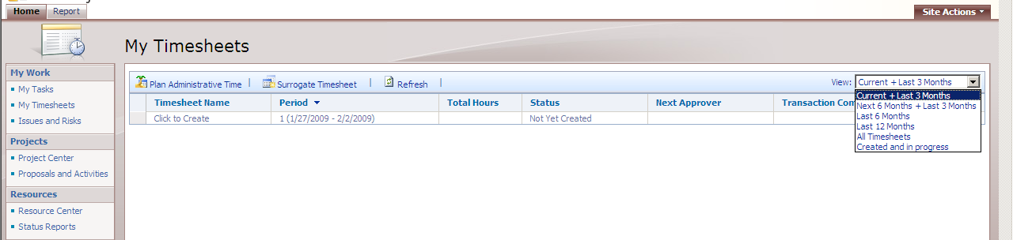
- From the view selection list on the right side of the page, select one of the following options:
  - Current + Last 3 Months
  - Next 6 Months + Last 3 Months
  - Last 6 Months
  - Last 12 Months
  - All Timesheets
  - Created and in progress
Note The Created and in progress view displays surrogate timesheets that you are currently responsible for, in addition to your own in-progress timesheets.
- To view the timesheet for that period on the My Timesheet page, click the name of a timesheet in the Timesheet Name column.

Submit my timesheet

After you enter your actual work (actual work: The amount of work that has been performed on a task or assignment. When you enter actual work on a task, the remaining work is calculated using this formula: Remaining Work = Work - Actual Work. Actual work is often referred to as "actuals.") on your timesheet (timesheet: In Project Web Access, the timesheet is a page where resources can record their progress on tasks and send updates to the project manager.) for a reporting period, you can submit your timesheet for approval.
- On the Quick Launch, under My Work, click My Timesheets.
- In the Timesheet Name column, click the timesheet that you want to submit.
If you do not see the timesheet that you want to modify, use the view selection list on the right side of the toolbar to view timesheets for different time periods.
- Type your hours for the reporting period in the grid.
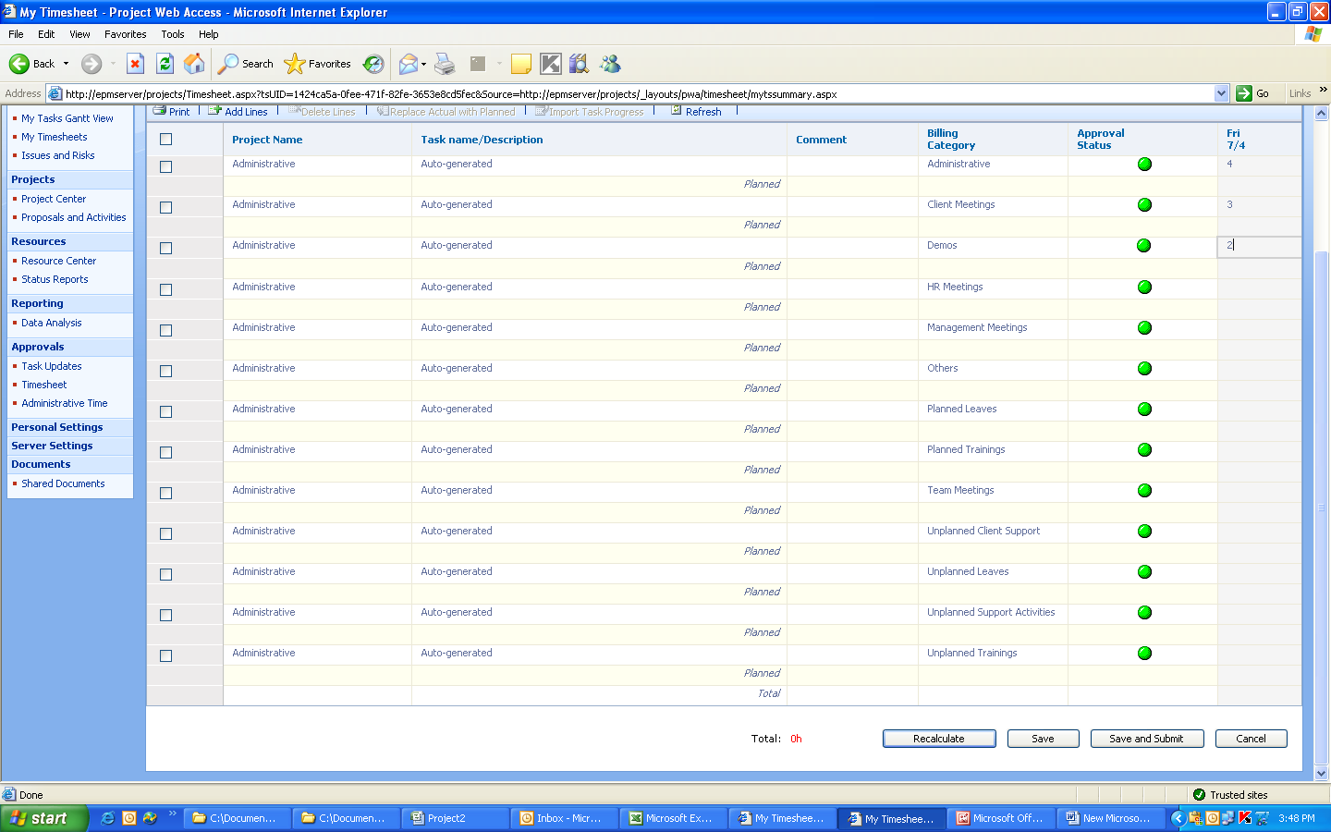

Tip If you want to send a comment to your manager about the time that you entered, click Settings, and then click Timesheet Header Data. Type your comment in the Comment box. If you want to rename your timesheet, type a new name in the Title box.
- Click Save and Submit to begin submitting your timesheet.
- In the dialog box that appears, verify that the name in the Pick next approver box is the correct approver for your timesheet. This box displays your manager's name, by default.
If the next approver is not your manager, type the name of the correct approver in the Pick next approver box, or click Browse to select the approver from a list of all Microsoft Office Project Server 2007 users in your organization.
- Type any additional comments that you want to send to the approver in the Comment box.
Note Your timesheet may need to be approved by more than one manager before your hours are reflected in the project. However, any administrative time that you submit may be reported without approval, depending on your organization's settings.

Recall a timesheet

If you submit, reject, or approve a timesheet (timesheet: In Project Web Access, the timesheet is a page where resources can record their progress on tasks and send updates to the project manager.) and then realize that you made a mistake or need to add a comment, you can recall the timesheet if it has not yet received approval from the final reviewer in the approval chain. Only timesheets with a status of Submitted or Acceptable can be recalled.
Note If you are the final reviewer in the approval chain and the timesheet is marked as Processed, it has already been processed and changes cannot be made through Microsoft Office Project Web Access. A third-party tool now owns the data.

Recall a submitted timesheet as a timesheet owner
- On the Quick Launch, under My Work, click My Timesheets.
- In the list of timesheets, select the timesheet that you want to recall.
- Click Actions, and then click Recall Timesheet.
- Click Yes to recall the timesheet.

Manage status reports
Status reports describe the progress on assigned tasks. Team members respond to status report requests from their managers and can also initiate the submission of status reports.

Submit a status report

A status report is a narrative description about whatever subjects are relevant to your organization. Typically, you submit status reports that were created for you by a manager. You can also create and submit your own unrequested status report at any time.
Submit a status report that was created for you
- Under Resources, click Status Reports.
- Under Responses, click the status report that you want to submit.
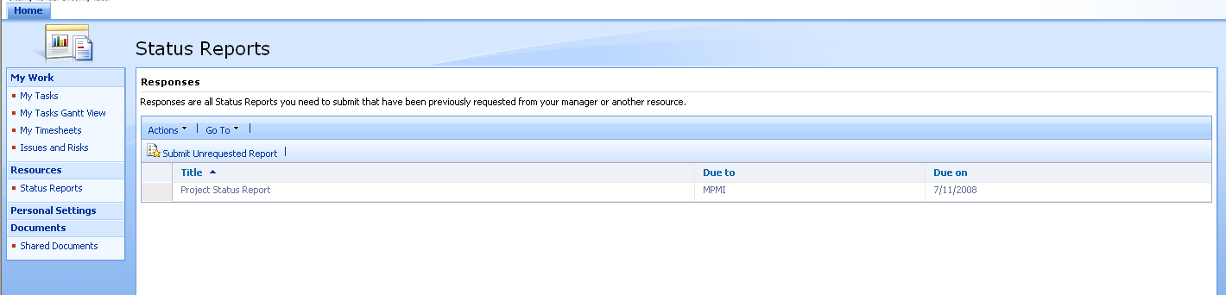
Note If you have upcoming status reports due, they are also listed on your Home page. You can write and submit the status reports from the Home page.
- On the Status Report Response page, enter the information that you want to submit. If you want to add an additional section, click Click to add section.
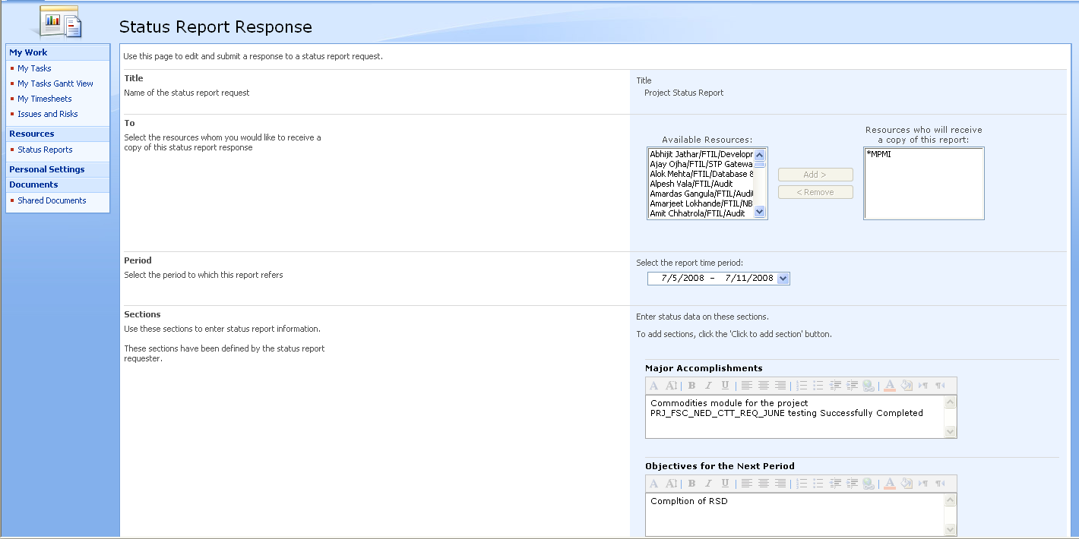
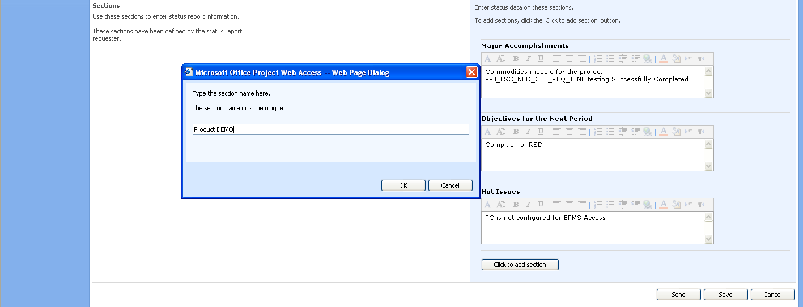
- Click Send.
Note To save the status report without submitting it to your manager, click Save. You can then add text to the report later and submit it when you are ready.
Tip To see a list of status reports that were filled out by team members, click Go To on the Status Reports page, and then click Status Reports: Archive.

Submit an unrequested status report
- Under Resources, click Status Reports.
- Under Responses, click Submit Unrequested Report.
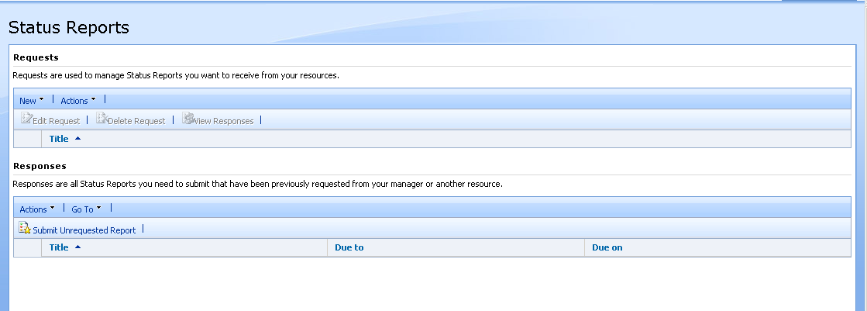
- On the Unrequested Status Report page, enter the information that you want to appear on your status report, including:
  - The title of the report.
Tip Since managers may see multiple status report requests, it is a good idea to include the department or project name in the status report name.
  - The name of the person who should review the status report. You can select more than one person's name, if needed.
  - The time period for which the status information is relevant.
  - The sections of the report. Click Click to add section to add sections to the report.
- Click Send.

Alert or remind me of changes with e-mail notifications

Notifications, also known as alerts and reminders, are e-mail messages sent by Microsoft Office Project Server 2007, based on settings that are defined in Microsoft Office Project Web Access.

About alerts and reminders
There are two types of notifications:
- Alerts You can set up alerts to receive e-mail notification immediately when some action has occurred with your task or status report. For example, you can turn on alerts that will notify you when you receive a new task assignment, or when you receive a new status report request.
- Reminders You can configure reminders to receive e-mail notification when your attention is needed on tasks and status reports. Reminders are based on conditions, such as a certain amount of time after an action occurs, and are sent according to a recurrence schedule that you define, such as every three days. For example, you can set up a reminder that will notify you a day before your status report is due, or that will send you recurring e-mail messages when your tasks are overdue by a certain number of days.
Managers can set up alerts and reminders for their resources. If your manager has done this, you will receive both the manager-defined notifications (for example, for overdue tasks or status reports) and the notifications that you define yourself.
Note If your manager has set up alerts that you do not want to receive, you can opt out of receiving those alerts. You cannot opt out of reminders that were set up by your manager.

Set notifications for yourself
- On the Quick Launch, click Personal Settings.
- Click Manage My Alerts and Reminders.
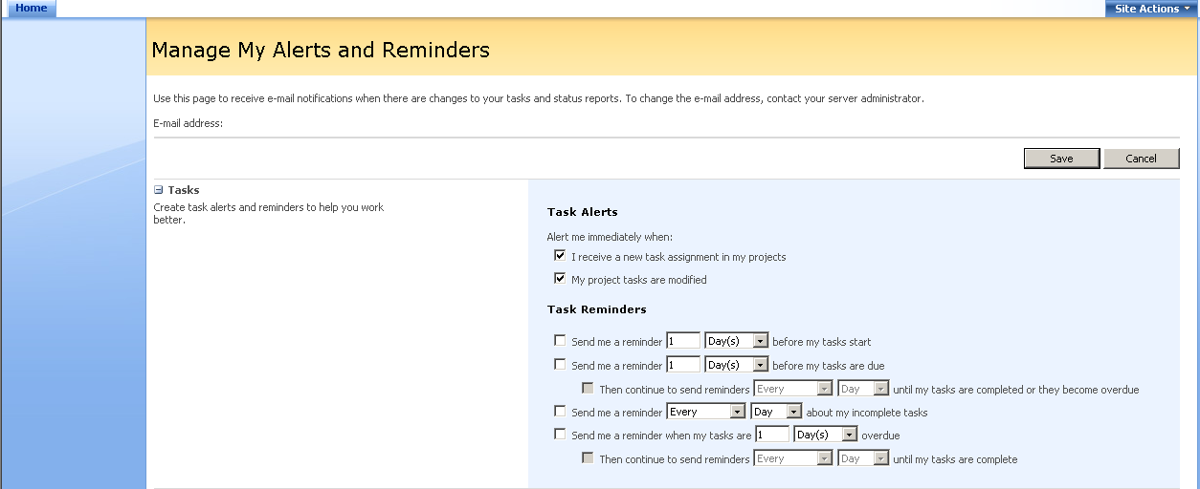
- In the Tasks and Status Reports sections, select the alerts and reminders that you want to receive.
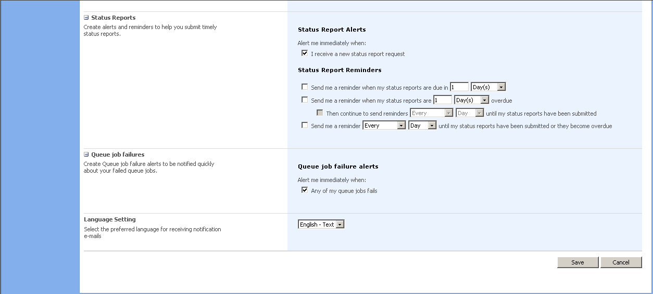
Note Reminders that are set up for you by your manager take precedence over your personal settings. For example, if your manager sets up a reminder to send you e-mail one day prior to when a status report is due, and you choose not to have reminders sent about your status reports, you will still receive the reminder set up by your manager.
- Specify the frequency at which you want your reminders to be sent.
- In the Language Setting section, select the language and format that you want to use for your notifications.
- Click Save to finish setting up your alerts and reminders.

Project Workspace
Project Workspace is basically a reserved space for that particular project where project team can share project related information like :
  - Can Upload Project related documents
  - Raise Issues or maintain issue Register
  - Create Risk if any
  - Schedule Meetings
  - Maintain Project discussions through discussion board
  - Track our Major deliverables also
For uploading project specific document, click on Project Document in quick launch
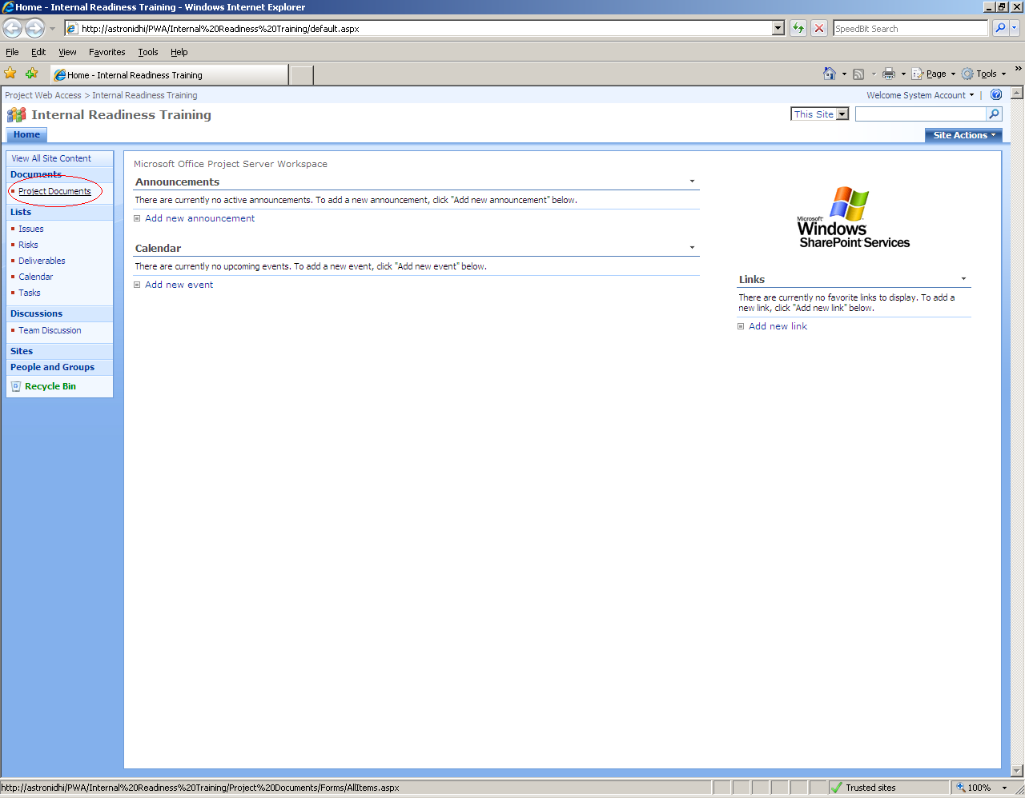
Uplaod a single or multiple document
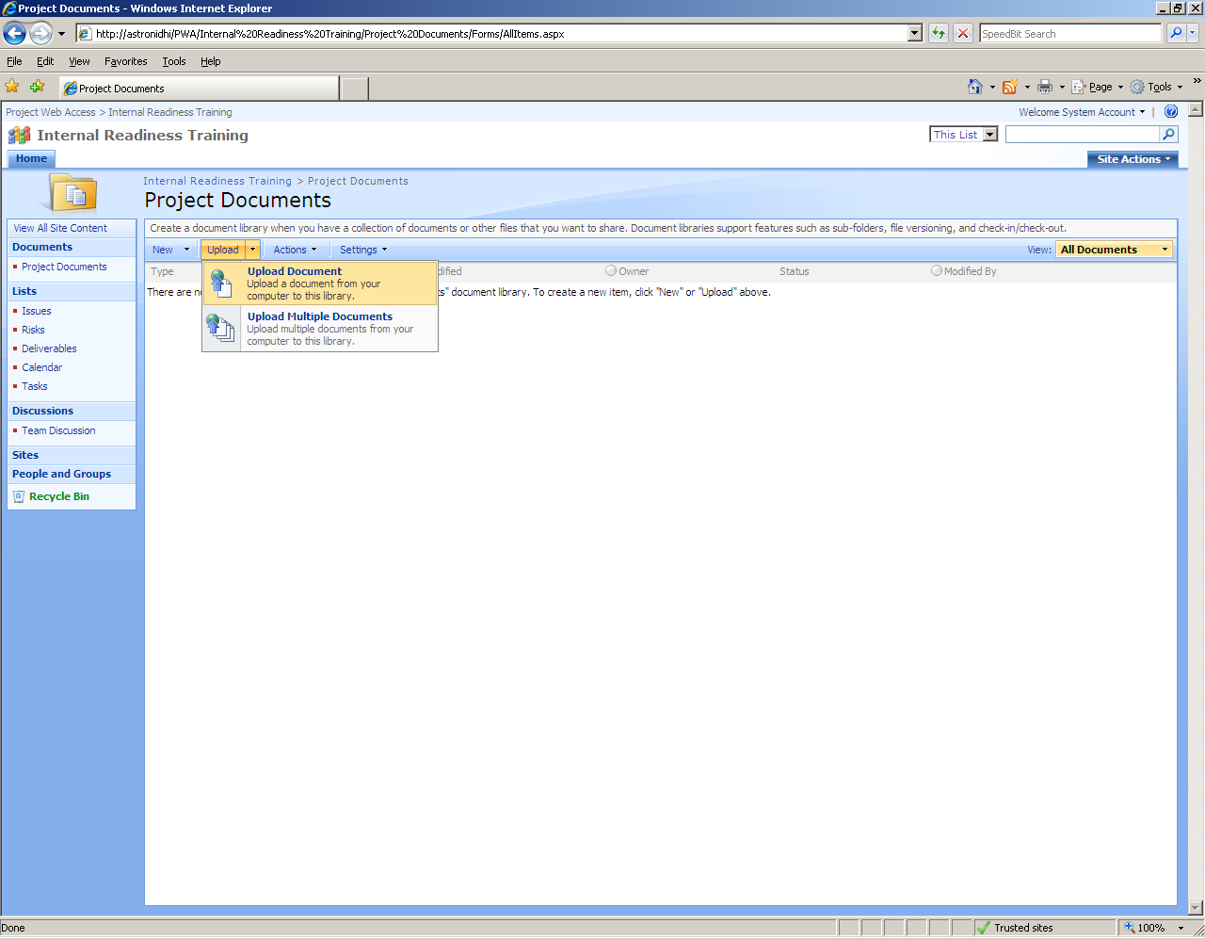
- Raise an Issue, click on Issue in Quick launch
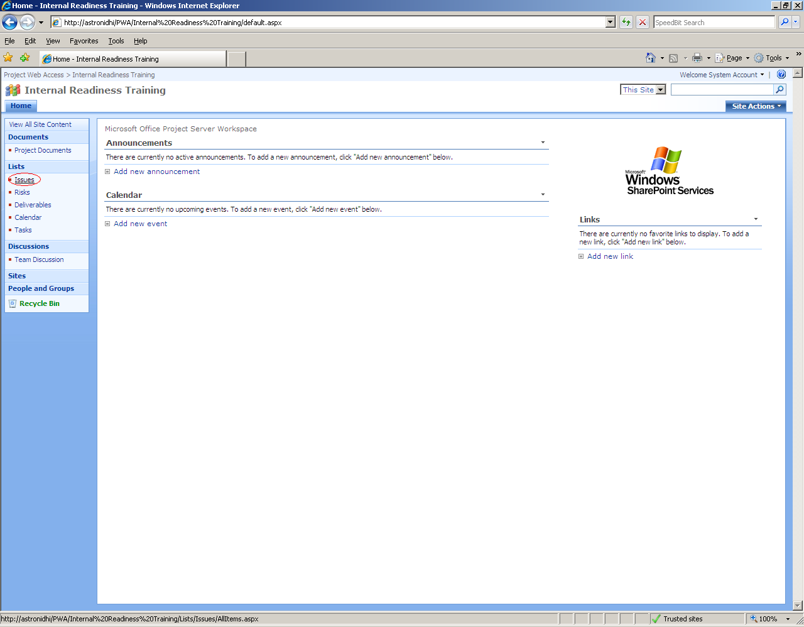
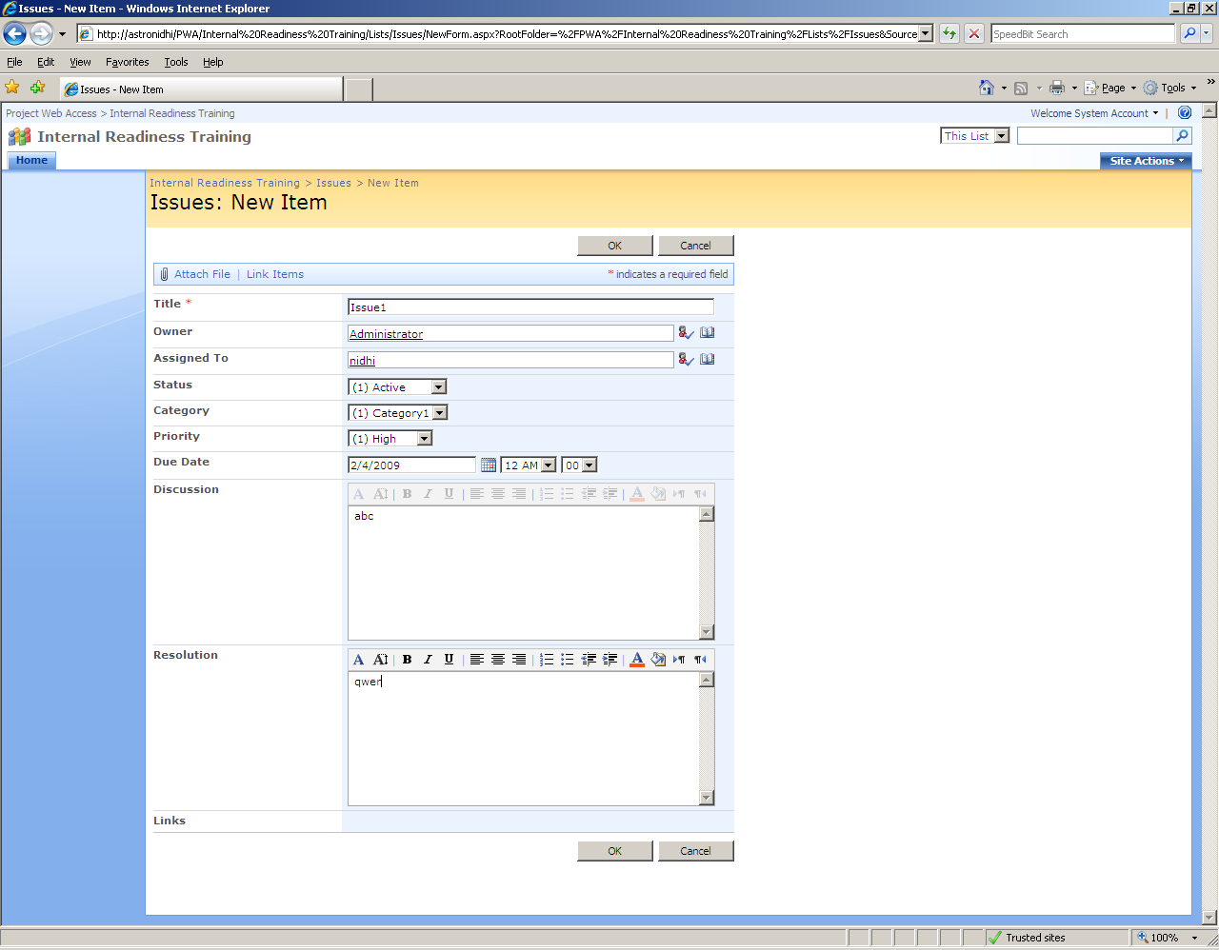
Same way we can create Risk also.
Major Deliverables if any in project, click on Deliverables in Quick launch
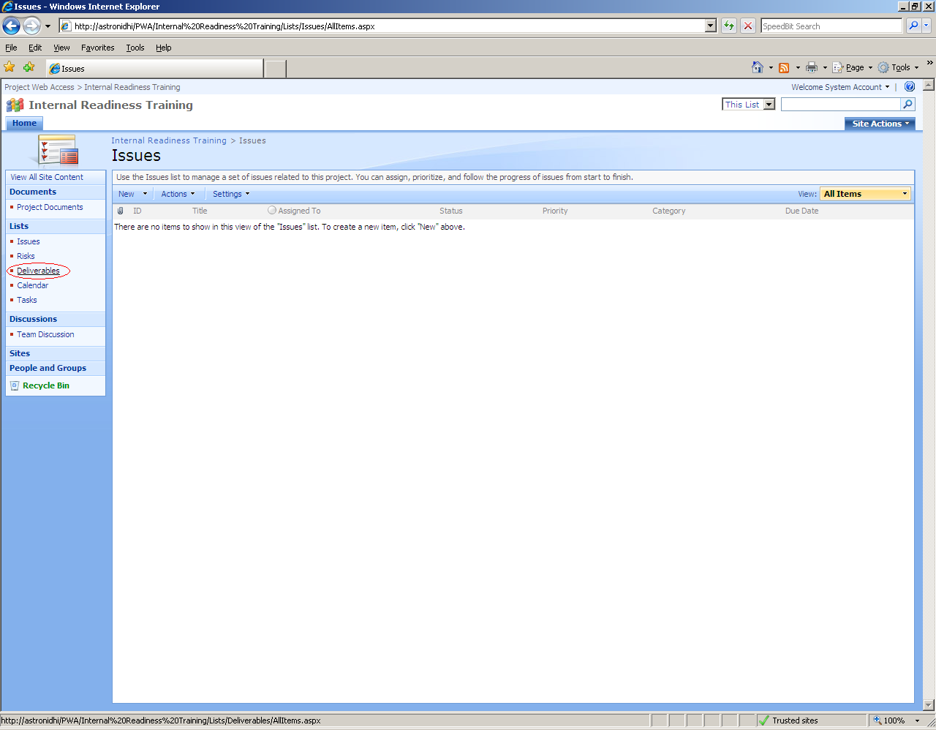
Enter Deliverable information
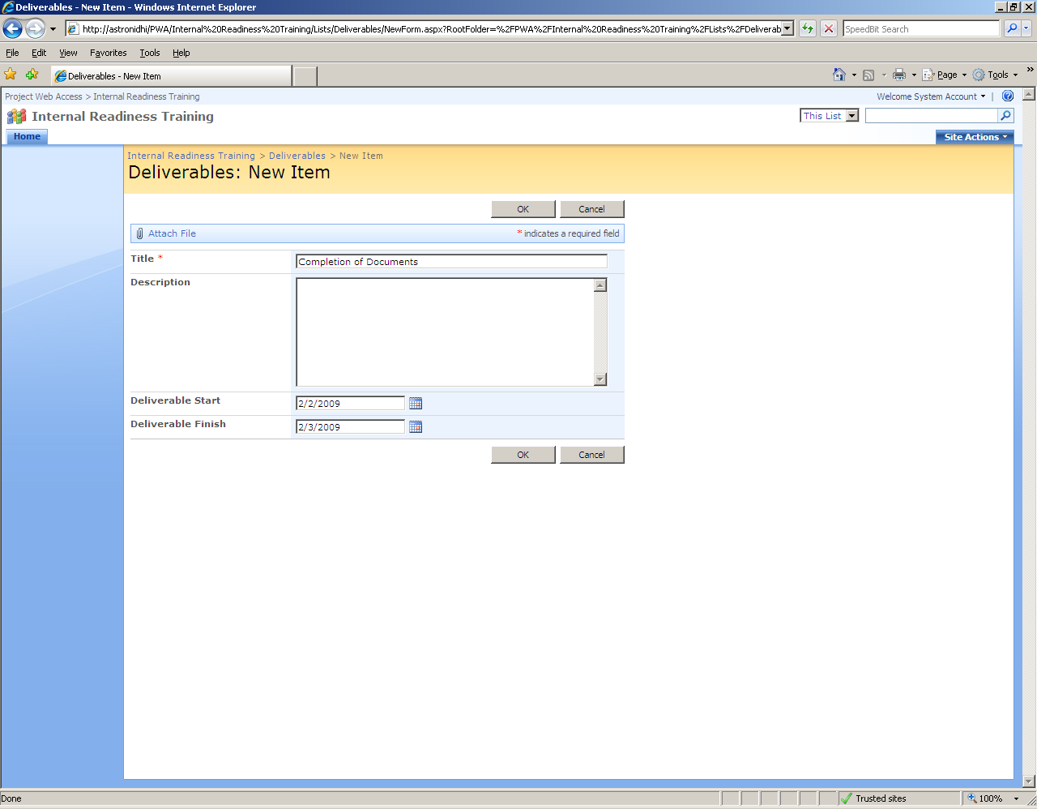
For Meeting Scheduler, click on calendar in quick launch and schedule meetings through new item.
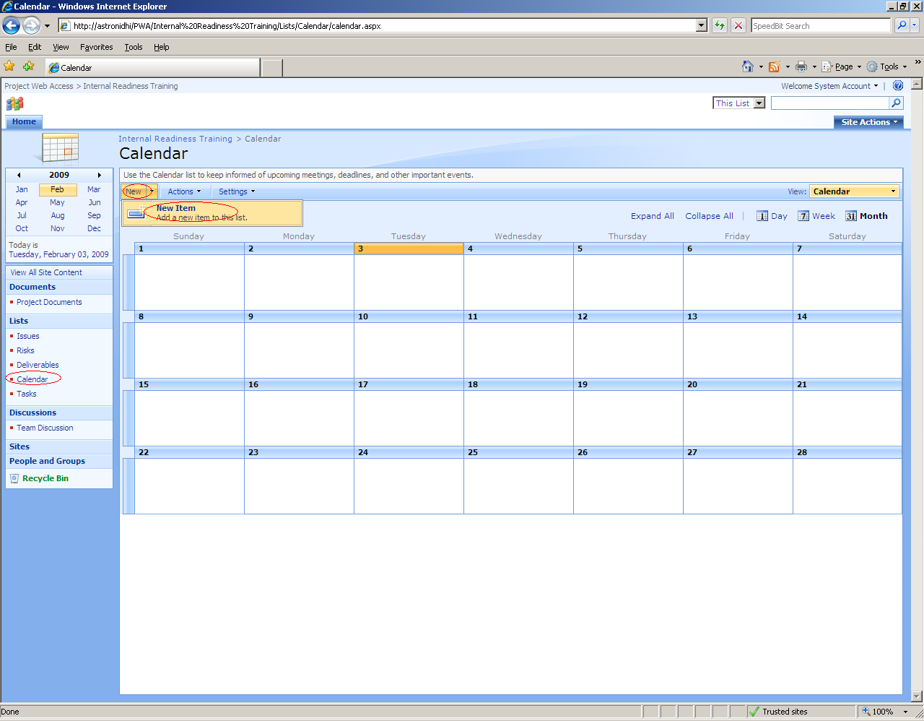
For Team Discussion, click on Team discussion under discussion in quick launch
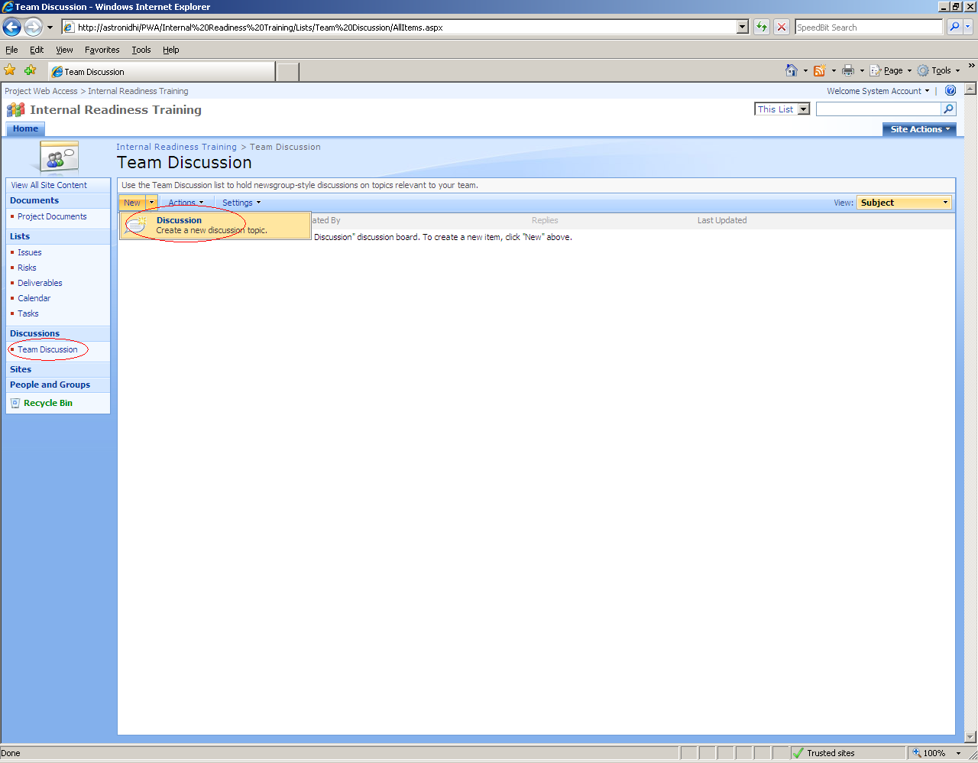

Through discussion board we can maintain complete project discussion with all reply
